Regional Sports Infrastructure Fund
[PROJECT NAME]
Project Plan

[APPLICANT]
[INSERT VERSION]
[INSERT DATE]

HOW TO USE THIS PROJECT PLAN TEMPLATE
This template provides instructions in blue italics to help applicants prepare their project plan. Please delete these prior to submitting your application.
KEY PROJECT DETAILS
PROJECT INFORMATION
Project name
Lead organisation name
Lead organisation ABN/ACN
Project partners
LEAD CONTACT
Name
Position
Phone
Email
Fax
Address
PROJECT SCOPE
Project summary for publication
(Can copy and paste from your online application)
PROJECT LOCATION
Address
Local government area
NSW electorate
SUPPORTING INFORMATION
Attachments  (Please list out all supporting information provided) | Attachment 1  Attachment 2

Contents
Contents
HOW TO USE THIS PROJECT PLAN TEMPLATE i
Contents i
1 Project Overview 1
2 Strategic Alignment 1
2.1 Strategic priorities for sport and recreation 1
2.2 Community support 1
2.3 Communication plan 1
3 Deliverability 1
3.1 Project milestones 1
3.2 Project benefits 1
3.3 Project risks 1
3.4 Non-financial assumptions 1
3.5 Procurement plan 1
3.6 Governance and partnership arrangements 1
4 Affordability 1
4.1 Budget template 1
4.2 Supporting information 1
4.3 Contingency 1

Document Control
Version | Status | Date | Prepared by | Amendments
0.1 | Draft | March 2018 | OoS SIG

Project Overview
Provide a high-level summary of the project, its background and what the project is aiming to achieve including:
- project objectives and scope
- total cost estimate (per budget)
- funding sought under Regional Sports Infrastructure Fund
- project type (e.g. regional sport hub, regionally significant sport facility)
- project deliverables (e.g. new facility, refurbished facility)
- project outcomes (e.g. increased participation, improved collaboration between sports)
Hint: Use SMART objectives

Strategic Alignment

Strategic priorities for sport and recreation
Describe the history and justification for the project (how it achieves the Regional Sports Infrastructure Fund objectives). Outline the urgency, continuing need, context, purpose of the project, and expected outcomes.
Applicants must demonstrate:
- an immediate and continuing need for the proposed project deliverables (the base case and case for change)
- the proposed project aligns with the Regional Sports Infrastructure Fund priorities and objectives
- the project aligns with a Council’s Community Strategic Plan and/or the facility plan of a state/national sporting organisation
- sport and social impacts of the project have been outlined and considered as contributing to the Regional Sports Infrastructure Fund objectives
- the project’s capacity to improve participation in sport and the use of sporting facilities.

Hint: Regional Sports Infrastructure Fund Objectives Summary
Regional Sports Infrastructure Fund objectives: | Increase the number and type of regional sporting facilities | Improve the standard of regional sporting facilities | Increase participation in sport

Hint: Focus of the Regional Sports Infrastructure Fund Priorities
Regional Sports Infrastructure Fund priorities: | Regional Sport Hubs | Regionally significant sport facilities

Community support
Please demonstrate your community’s support, including sporting clubs and association for the project. The response should show:
- community/stakeholder views have been considered in developing the project (key stakeholders are identified, consulted and their opinions incorporated into plans)
- the expected sport and recreational benefits for the community as a result of delivering your project
- the community/stakeholders, including state/national sporting organisation, support of the project and agree on the expected benefits.
The response from your Expression of Interest application and any previous letters of support may form the basis of your response here.
A letter of support from the relevant state/national sporting organisation(s) is mandatory.
Applicants are recommended to provide evidence of support from as many stakeholder groups as possible. Examples of evidence include (but are not limited to):
- letters of support from any stakeholders
- confirmation letters for financial or in-kind support
- petitions
- surveys
- public consultation
- newspaper articles.

Communication plan
The communication plan details how you will engage with your community and ensure they are informed of key information about your project. List the key stakeholders (internal and external) who will have an impact on the project or be affected by the project, and describe how they will be engaged. Summarise the overall key communication and management issues for the project, concentrating on what will contribute to the project’s success or where a lack of communication can lead to failure. Describe how they will be affected by the change.
Communication Plan
Who  Name of person or group | Why  Why are they involved/ have interest in the project? | What  What information do they need? What are the key messages that need to be sent? | How  How will they receive this information e.g. status reports, newsletters, phone.)? Who will send it? | When  When will this communication occur?

Deliverability

Project milestones
Define and sequence key activities to be undertaken to deliver the project from the beginning to the end (planning, implementation, construction, etc.). Projects should be completed within three years of funding approval. Estimate the duration for each activity. Key events to consider for incorporation into the program:
- Review period
- Planning and detailed design
- Approvals
- Procurement
- Development/construction
- Commissioning
- Opening date
- etc.

Project Milestones / Deliverables
No. | Product, services and/or results that the project will deliver | Estimated start date | Estimated completion date | Estimated cost
1 | Engage contractor to develop detailed plan | 1 Nov 2018 | 1 Nov 2018 | $25,000
2 | Sign off plan | 1 Dec 2018 | 15 Feb 2019 | $10,000
3 | Site preparation works | 2 Mar 2019 | 22 Mar 2019 | $210,000
4 | Installation of grandstand and fields | 27 Mar 2019 | 5 May 2019 | $1,004,000

Project benefits
List all benefits that will be created as a result of the project. Key benefits from the project may include improved access for people with disability, female friendly amenities, increased sport participation, hosting of state championships, social benefits, coordinated service delivery etc. Ensure you identify who the beneficiaries are and the type and timing for when they are to receive the expected benefits. Quantify benefits and number of people included in a beneficiary group wherever possible.
Benefits*
Benefit/s that the project is expected to yield | Who will receive this benefit? | Estimated timeframe for when the benefits will be received
e.g. Increased access to national sporting events for the regional community and tourists resulting in 10 additional events per year | Local community (20,000 population) and visitors | Jun 2019 (on project completion)

Project risks
Detail the key risks that could impact on this project; select from the “drop-down menu” provided to outline the likelihood, consequence and rating. Describe the actions that will be used to manage these risks or describe how these could be prevented or dealt with if they do occur.
Some examples of risks include cost, schedule/timeframes, legal, public relations, safety, technical, environmental, etc.
The risk matrix below can be used to assign the risk rating (Low, Medium, High and Extreme) in the table. For example, if a risk event i.e. a weather event interrupts construction and sets back the completion date meaning that the venue won’t be open for a key event. The likelihood of this happening may be ‘Unlikely’ but the impact might be major. The resulting risk rating is ‘High’.
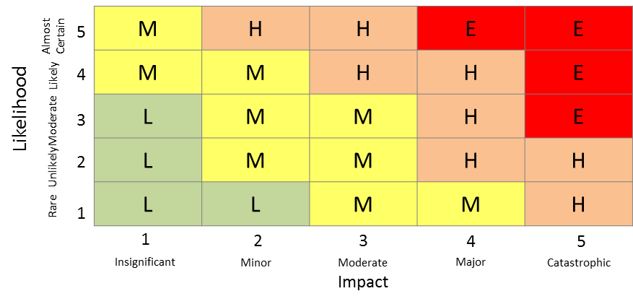
Risk Name | Owner | Likelihood | Impact | Risk Rating | Risk Treatment Actions
Risk 1:  What might happen? What would the impact be if it came true? | Who is responsible? | Moderate | Major | High | What action will be taken to prevent this risk from occurring and/or reduce its impact on the project?  For example:  Avoid – plan around it  Mitigate – reduce probability and/or impact  Eliminate – reduce probability to zero (impossible to  occur)  Transfer – transfer the risk to another person/organisation through insurance or contracts  Accept – choose to do nothing, monitor for change
Risk 2: |  | Choose an item. | Choose an item. | Choose an item.
Risk 3: |  | Choose an item. | Choose an item. | Choose an item.
Risk 4: |  | Choose an item. | Choose an item. | Choose an item.
Risk 5: |  | Choose an item. | Choose an item. | Choose an item.
Risk 6: |  | Choose an item. | Choose an item. | Choose an item.
Risk 7: |  | Choose an item. | Choose an item. | Choose an item.
Risk 8: |  | Choose an item. | Choose an item. | Choose an item.

Non-financial assumptions
Detail all non-financial assumptions needed to deliver the project.
Non-financial assumptions may include things like permission to build, ownership rights, other grants, decisions of council / board, heritage considerations, etc. Please also ensure these are addressed in the risk section if appropriate.

Procurement plan
Detail how a project team will acquire goods and services to deliver the project.

Governance and partnership arrangements
Detail all governance and partnership arrangements throughout all phases of the project delivery (i.e. roles, responsibilities and accountabilities allocated to everyone involved in the project). Ensure that the responsibilities for the project manager are detailed. If the person responsible for approving payments is not the project manager then this person or group must be identified separately. If there is a Steering Committee or Board this must be included. Ensure all other individuals and groups who provide guidance, authority, input and support are included. If the project location is on land not owned by the applicant, details of the tenure and lease agreement and asset ownership and maintenance should be outlined.
Governance Plan - Project team
Project role | Name | Phone | Email | Responsibilities | Reports to
Project Manager
Cost Approver

Affordability

Budget template
Please complete the excel budget template available online. It includes project and ongoing costs.

Supporting information

Applicants will be required to provide supporting documents including (but not limited to):
- Copy of most recent Bank Statement
- At least one quote for key budget items. All quotes must contain the supplier's business details including address.
- Legal name per the Australian Securities and Investments Commission (ASIC) database
- Copy of organisation’s current constitution (if a registered organisation)
- Confirmation of signatory details (person/s authorised to sign contracts on behalf of the organisation)
- Australian Business Number (ABN) and, if registered for GST, your Australian Business Register (ABR). An ACN should also be provided where you have one.
- Copy of last three years of audited financial statements (where available)
- Statement of Financial Position / Statement of Profit and Loss for the past three years (where applicable)
- Provide further evidence to support the budget particularly for any forecast costs (i.e. expected costs to operate or maintain the proposed project in the future).
- Outline whether the funding is for a new or existing asset.
Only projects with a minimum financial co-contribution of 25 per cent of the total grant amount will be considered, unless financial hardship can be demonstrated. Projects with greater financial co-contribution will be considered favourably.

Contingency
Please provide your breakdown and justification for contingency amounts included in the budget template.

